**Python Basic Discussion and Installation**

**Introduction**

In this lecture, The roadmap or the syllabus of this course was discussed and a guideline was provided on how to install Anaconda on a desktop computer and how to use Jupyter notebook as an editor. Note that, A video link was also provided on the installation of Anaconda but still the instructor showed it to the students again.

**Roadmap Discussion**

The roadmap or the syllabus of this course was divided into multiple segments and those segments are provided below.

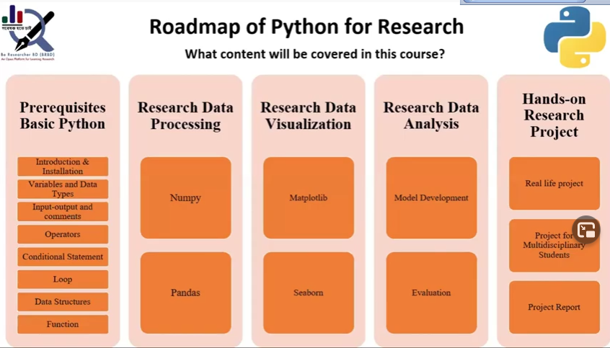

In the first segment named “Prerequisites of Basic python, the topics are represented below.

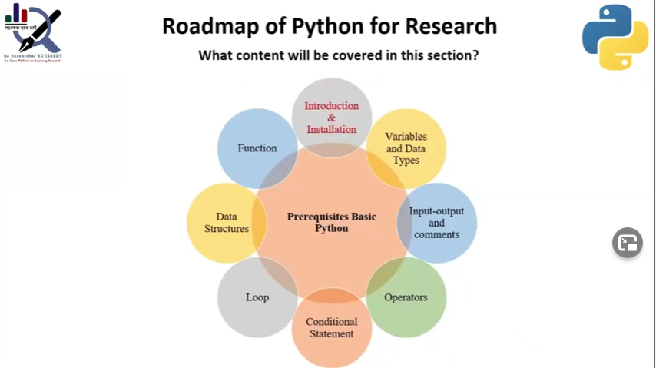

**Course introduction**

This course is called python for research and the main difference between this course and classical python is that It is designed for multidisciplinary students so they can learn and use this knowledge in their own respective fields. The other key features of this course is,

* This course focuses on both the theoretical and practical parts of python. This is different than other classical python courses.
* Huge scope of practice.
* Assignment based on every lecture.
* Students should submit a summary after every lecture.
* Group discussion opportunity.
* Class notes and sources are provided.
* Class recorded videos are also provided.
* Q/A session.
* Solution class.
* Real-life project for multidisciplinary students.
* Team formation based on the performance and background of the students.
* Research guideline.

**Anaconda installation**

Jupyter notebook of Anaconda is a popular python editor and the mentor demonstrated how to download and install anaconda and jupyter notebook on one’s computer in the live class.

**Conclusion**

This first class of this course gave an overall idea to the students what are the outcomes that they can expect from this course, what is it about and why it is different than any classical python course, and how to download and install a python editor in their own computer.

**Reference**

* Mahmudul Hasan Moon, Basic discussion and installation, "Be researcher BD | Python for research", Md. Sabir Hossain(Youtube)